**Race Venue Lodging Information 2024**

**Bend**

* Onsite
  + Mt Bachelor Ski Resort, 13000 SW Century Dr, Bend OR

**Newport**

* Currently there are no on-site options, but they are looking into using nearby airfield.
* **South Beach State Park**
  + [**South Beach State Park Newport**](https://oregonstateparks.reserveamerica.com/camping/prineville-reservoir-state-park/r/campgroundDetails.do?contractCode=OR&parkId=402461#sr_a)
  + 5580 S Coast Hwy South Beach, OR 97366
  + Call for reservations: 800-452-5687  
    Call for info: 800-551-6949  
    Call park: 541-867-4715

* **Holiday Inn Express**
  + 135 SE 32nd Street, Newport, OR 97365 United States
  + 541-867-3377 (front desk)
  + 888-465-4329 (Holiday Inn main number)

* **LaQuinta**
  + [**LaQuinta Newport**](https://www.wyndhamhotels.com/laquinta/newport-oregon/la-quinta-newport/overview?CID=LC:6ysy27krtpcrqev:53341&iata=00093796)
  + 45 South East 32nd St., Newport, OR, 97365
  + 541-867-7727

Madras

* **Onsite** – mowed/sandy open area, dry and dusty. No electricity. Bathroom w/o shower withing walking distance. Near playground.
  + Madras East Hills Trail System, E Ashwood Rd, Madras, OR 97741
* **Econo Lodge Inn & Suites Madras**
  + [**Econo Lodge Madras**](https://www.choicehotels.com/oregon/madras/econo-lodge-hotels/or187?mc=smbibiusell&cid=us_ch_econo-lodge_search_bng_b%2Bg_conv_oregon&ag=US_OR_Madras_Location_Exact&pmf=BING&kw=econo+lodge+madras+or&=undefined&msclkid=782118a5a33f193fc0f97d4d66c1abdd&utm_source=bing&utm_medium=cpc&utm_campaign=us_ch_econo-lodge_search_bng_b%2Bg_conv_oregon&utm_term=econo%20lodge%20madras%20or&utm_content=US_OR_Madras_Location_Exact&gclid=782118a5a33f193fc0f97d4d66c1abdd&gclsrc=3p.ds)
  + 651 N Hwy 26, Madras, OR 97741
  + 541-475-4633

* **Quality Inn**
  + 12 SW 4th, Madras, OR 97741
  + 541-475-6141

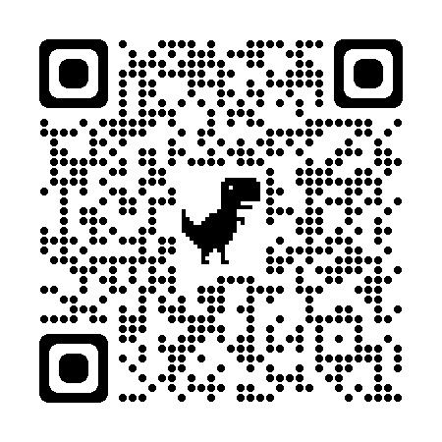

* **The Bunkhouse at Cross Keys**
  + 706 NW Bunkhouse Rd., Madras, OR 97741
  + 541-475-8668

**Prineville**

* **Onsite** – mowed Grassy open area, dry and dusty.No electricity. Porta Potties. A good time!
  + 1875 NE Ironhorse Dr, Prineville, OR 97754
* **Prineville Reservoir State Park**
  + [**Prineville Reservoir State Park**](https://oregonstateparks.reserveamerica.com/camping/prineville-reservoir-state-park/r/campgroundDetails.do?contractCode=OR&parkId=402461#sr_a)
  + 19300 SE Juniper Canyon Rd, Prineville, OR 97754
  + Call for reservations: 800-452-5687  
    Call for info: 800-551-6949  
    Call park: 541-447-4363

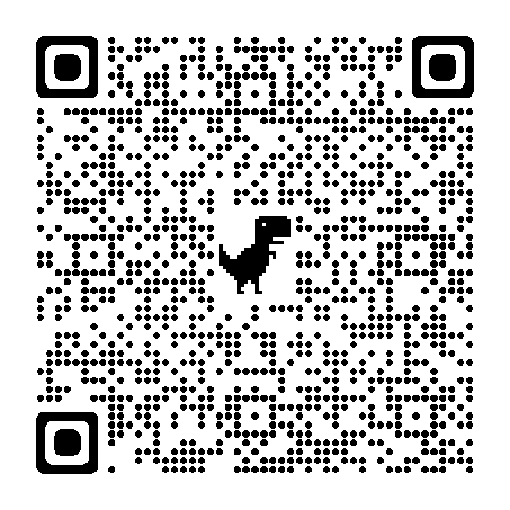

* **Best Western Prineville**
  + [Best Western Prineville](https://www.bestwestern.com/de_DE/book/hotel-rooms.38124.html?iata=00171890&ssob=BLBWI0003G&cid=BLBWI0003G:yext:website:38124)
  + 1475 NE 3rd St, Prineville, OR 97754
  + Hotel Direct Number 541-447-8080

* **Country Inn & Suites by Radisson**
  + [Country Inn & Suites By Radisson Prineville](https://www.choicehotels.com/oregon/prineville/country-inn-suites-hotels/or345?cid=a:rf+b:yex+c:amer+i:local+e:cis+d:us+f:en-US+h:USACIPO)
  + 1773 Northeast 3rd Street, Prineville, OR, 97754
  + 541-447-7100

